**Project Design Phase-II**

**Data Flow Diagram & User Stories**

|  |  |
| --- | --- |
| Date | 27 June 2025 |
| Team ID | LTVIP2025TMID21127 |
| Project Name | Sustainable Smart City Assistant |
| Maximum Marks | 4 Marks |

**Data Flow Diagrams:**

A **Data Flow Diagram (DFD)** is a traditional visual representation of the flow of information within a system. It illustrates how data enters and leaves the system, what processes transform the data, and where the data is stored. A well-structured DFD helps in understanding the system's functionality and requirements by clearly showing the movement and handling of data at different levels.

**Data Flow Diagram (DFD):**

**Level 0 - Context Diagram:**

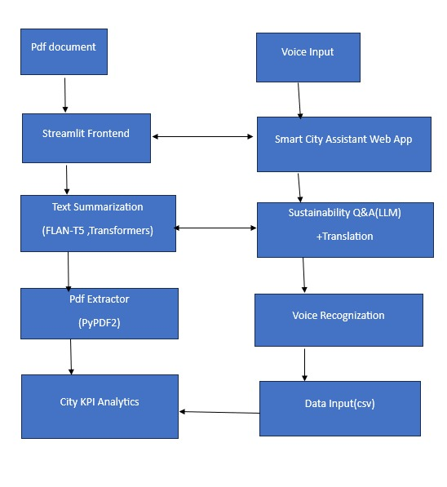

**User Stories**

Use the below template to list all the user stories for the product.

| **User Type** | **Functional Requirement (Epic)** | **User Story Number** | **User Story / Task** | **Acceptance criteria** | **Priority** | **Release** |
| --- | --- | --- | --- | --- | --- | --- |
| Citizen(web) | Document Upload | USN-1 | As a user, I can upload policy documents (PDF) to get summarized insights. | PDF is uploaded and summary is generated. | High | Sprint-1 |
| Citizen(web) | Text to Text QA | USN-2 | As a user, I can ask sustainability questions and receive AI-generated answers. | Answers are accurate and appear on screen. | High | Sprint-1 |
| Citizen(web) | Translation | USN-3 | As a user, I can view answers in local language (e.g., Hindi, Telugu). | Answers translated accurately. | Medium | Sprint-2 |
| Citizen(web) | Voice Interaction | USN-4 | As a user, I can speak questions using my microphone. | Voice is captured and converted to text. | Medium | Sprint-2 |
| Citizen(web) | Issue Reporting | USN-5 | As a user, I can report sustainability issues from the app. | Confirmation is shown after submission. | Medium | Sprint-  1 |
| Citizen(web) | View KPI Data | USN-6 | As a user, I can upload KPI data and see trends and anomalies. | Graph is shown; anomalies highlighted. | High | Sprint-1 |